Preliminary Design

1. Introduction
   1. Objective
      1. According the preliminary design, design the training items in the general terms.
   2. Information
      1. The training items of AP Office.
2. Overall Design
   1. Requirements
      1. Import: Get the data from the different of files.
      2. Export: Show the data on the picture and save the picture.
   2. Operating Environment
      1. Windows System.
   3. Handing

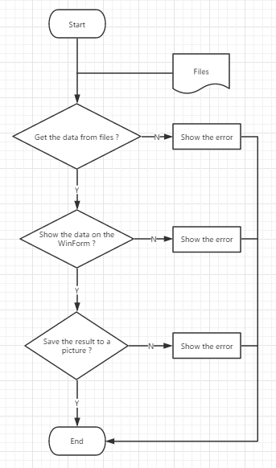

* 1. Structure

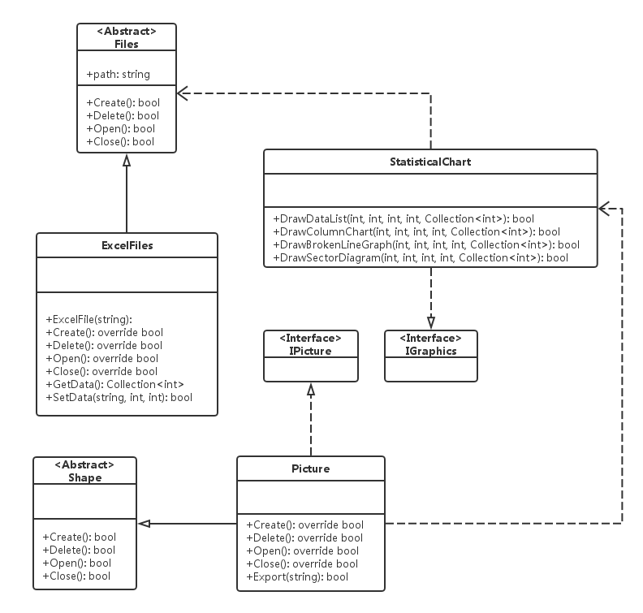

* 1. Manual Handing
     1. Select a file to get the data.
     2. Click the button to save the result to a new picture.

1. Interface Design
   1. Internal Interface
      1. IGraphics: Show the data on the data list, column chart and sector diagram.
      2. IPicture: Save the result as the picture.
2. Operation Design
   1. Operation Mode
      1. <Abstract>Files: As an abstract class is inherited.
      2. ExcelFiles: Get the data from excel files.
      3. Graphics: Show the data and save the result as a picture.
   2. Operation Control
      1. Provide the file path before using the program.
      2. Select the button to save the result as a picture.
   3. Operation Time
      1. If the mass of data need to be get, it took a few minutes.
3. Data Structure Design
   1. Logical Structure
      1. Files:

path string

data Collection<int>

* 1. Physical Structure
     1. Program get the data from the files and show them through a picture.

1. Error Handing Design
   1. Error Message
      1. Cannot get the data from files.
      2. Cannot show the data on the WinForm.
      3. Cannot save the result as a picture.
   2. Error Handing
      1. Check the path of the provided files.
      2. Check the code.
   3. Maintain Design
      1. Add the function could complete through the class inherit.